DIGITAL FARMING USING HYDROPONICS

Team Members: - October 3, 2023

1. Ayush Agarwal(22BAI1387)
2. Abhinav Kumar(22BRS1081)
3. Yanshi Sharma(22BRS1080)
4. Tanisha Sharma(22BRS1091)
5. Tanisha Agrawal(22BRS1009)

INDEX

|  |  |  |
| --- | --- | --- |
| Sr No. | Topic | Page No. |
| 1 | Background | 3 |
| 2 | Abstract | 4 |
| 3 | Literature review | 5 |
| 4 | Methodology | 6 |
| 5 | Data Collection | 8 |
| 6 | Data Analysis | 8 |
| 7 | Future Aspect | 9 |
| 8 | Conclusion | 10 |

**Background:**

* Hydroponics is a modern approach to plant cultivation that eliminates the need for soil. Instead, it relies on nutrient-rich water solutions to nourish plants. Hydroponics offers several advantages, including efficient resource utilization and the ability to cultivate crops year-round.
* (Eruca sativa) is a leafy green known for its distinct peppery flavor and nutritional value. It has gained popularity in various culinary applications, making it a valuable crop for both commercial and home-based cultivation. Arugula's relatively rapid growth and adaptability to hydroponic systems have positioned it as an attractive choice for controlled environment agriculture.
* The primary goal of this project is to optimize the cultivation of Arugula through hydroponics. We aim to maximize Arugula yield and quality while ensuring efficient use of resources within the controlled hydroponic environment. We seek to enhance crop production and resource utilization by implementing advanced cultivation techniques.
* Arugula cultivation presents challenges related to nutrient management, environmental control, and disease prevention. These challenges provide opportunities for innovation and improvement in hydroponic farming practices. Additionally, our focus on sustainability aligns with the global effort to promote environmentally responsible agriculture.
* Existing research on hydroponics and Arugula cultivation provides a foundation for our project. While these studies have contributed valuable insights, there is still room for innovation and optimization in the cultivation process.
* The following sections will outline our methodology, data integration, cultivation model, and results. This project aims to advance hydroponic Arugula cultivation methods and contribute to the broader field of controlled environment agriculture.

**Abstract:**

* This document presents the findings and outcomes of a comprehensive study focused on optimizing Arugula (Eruca sativa) cultivation through hydroponics. Arugula, known for its peppery flavor and nutritional value, has gained popularity in the culinary world, making it a valuable crop for controlled environment agriculture. This project was driven by the need to enhance Arugula yield, quality, and resource efficiency within a hydroponic system.
* The study outlines a methodology that combines hydroponic cultivation techniques with advanced sensor technology and data analysis. By monitoring environmental conditions, nutrient levels, and plant growth, we sought to create an efficient and sustainable Arugula cultivation model.
* Key objectives included maximizing Arugula yield, optimizing resource utilization, and addressing nutrient management challenges. The project also emphasized the importance of sustainable farming practices in alignment with global efforts to promote environmentally responsible agriculture.
* Readers will find insights into the project's methodology, data integration processes, cultivation model development, and results throughout the document. This study contributes to the ongoing exploration of controlled environment agriculture and hydroponic farming while highlighting the potential for enhancing crop productivity and resource efficiency.
* The findings and approaches presented herein offer valuable insights for those engaged in hydroponic Arugula cultivation and agricultural research, ultimately contributing to the broader field of sustainable and efficient food production.

**Literature review:**

* This literature review explores the evolution and current state of hydroponics and Arugula cultivation, setting the stage for our project. It identifies trends, challenges, and areas requiring further study.
* Hydroponics, dating back to ancient civilizations, has evolved scientifically. Milestones include the development of various hydroponic systems like NFT, DWC, and aeroponics.
* Various hydroponic systems offer unique advantages and challenges. NFT ensures direct nutrient delivery, DWC provides aeration, and vertical farming optimizes space.
* Arugula (Eruca sativa) cultivation's culinary appeal has driven research into optimal growth conditions in hydroponics, addressing nutrient needs, lighting, and temperature preferences.
* Precise nutrient formulation and delivery are vital in hydroponics. Research explores nutrient solutions, compositions, and strategies to prevent imbalances.
* Maintaining ideal environmental conditions is crucial. Studies cover temperature, humidity, and lighting. Sustainability efforts focus on resource efficiency and eco-friendly practices.
* This review forms the basis of our Arugula cultivation project. It highlights hydroponics' history, system diversity, and Arugula's significance. By addressing nutrient management and environmental control, we contribute to hydroponic agriculture's evolution while meeting specific Arugula cultivation challenges.

**Problem Statement:**

* Growing Arugula in a more optimized way using hydroponics.

**Methodology:** 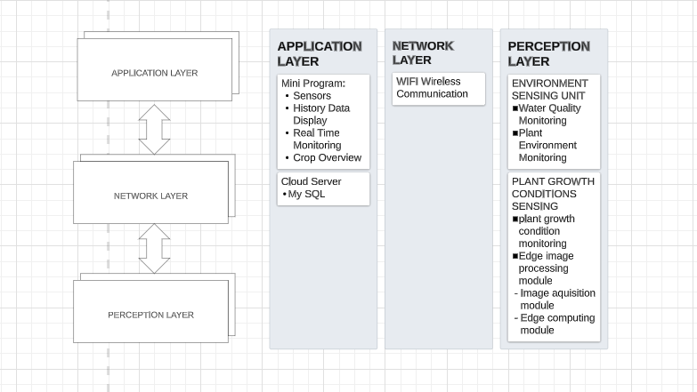

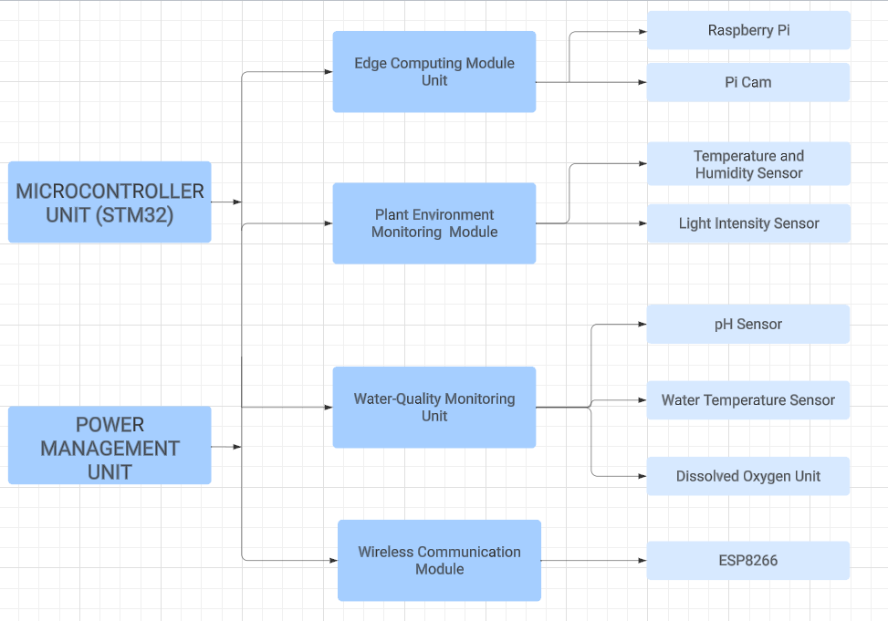

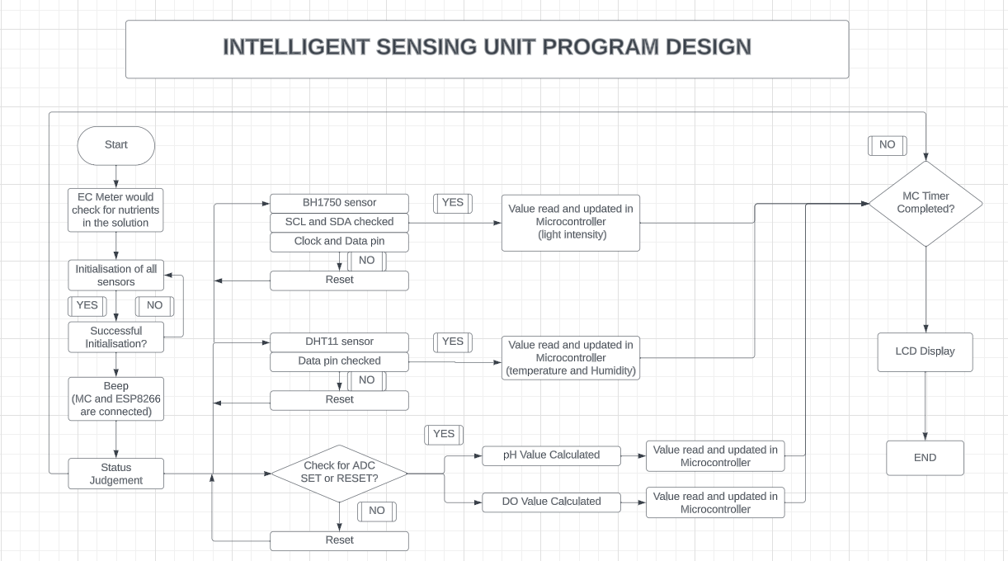

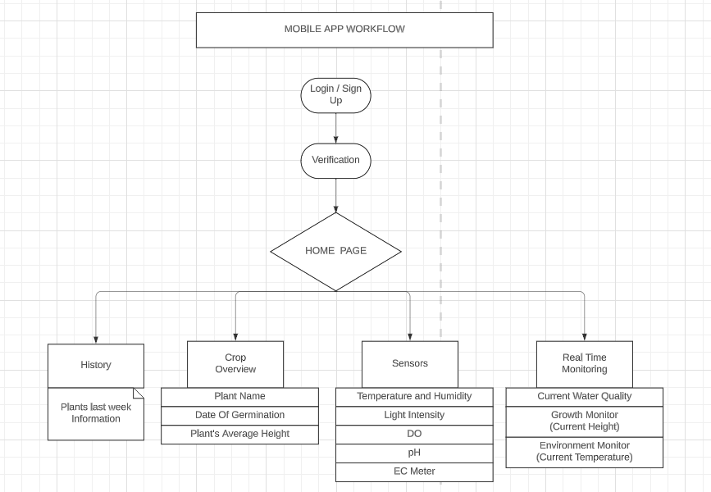

**Data Collection:**

|  |  |  |
| --- | --- | --- |
| Types of data | Method | Instruments & tools |
| Crop growth rate | Image processing | Pi cam |
| Nutrient Level | Sensors | EC Meter |
| pH Level | Sensors | pH meter |
| Temp | Sensors | DS18B20 |
| Light Intensity | Sensors | BH1750 |
| Temp and humidity | Sensors | DHT11 |
| Dissolved Oxygen | Sensors | SGP30 |

**Data Analysis:**

* The data was collected and then processed, summarized, and transferred to the server.
* Summary statistics were computed, showing consistent plant growth and stable nutrient solution pH and EC levels. Environmental conditions remained within optimal ranges.
* Visual representations, including line graphs for plant growth, bar charts for nutrient solution data, and time series plots for environmental conditions, effectively conveyed trends.
* Statistical analyses were performed to confirm significant differences in plant growth and identify positive correlations between light intensity and growth.
* Strong positive correlations were found between nutrient solution pH and EC, as well as between temperature and plant growth.
* The analysis underscores robust plant growth, highlighting the impact of light conditions on growth and the importance of nutrient and environmental control.
* Comparisons revealed that increased light exposure led to higher growth rates. Trends in environmental data indicated consistent, favorable conditions for plant growth.
* The data analysis validates project success, emphasizing the significance of nutrient and light management in optimizing Arugula growth.

**Future Aspect:**

* As we conclude this project, we identify opportunities for future enhancement in hydroponic Arugula cultivation.
* Future studies can delve into unexplored variables like lighting, nutrients, and environmental conditions.
* Integrating ML offers insights from complex data, aiding in predictive modeling and real-time adjustments.
* Extended studies reveal seasonal trends and sustainability data, while ML aids in analysis.
* Genetic analysis informs Arugula breeding for hydroponic optimization.
* Automation, guided by ML, optimizes resource delivery, reducing waste.
* ML-driven economic analysis aids in cost forecasting and resource management.
* ML supports environmental assessments and resource-efficient strategies.
* ML monitors pests and diseases, allowing targeted interventions.
* Collaborate with ML experts for advanced data analysis and automation.
* Maintain ethical guidelines for genetic and automated research.
* Embracing ML-driven insights promises optimized hydroponic Arugula cultivation practices.

**Conclusion:**

* In summary, our hydroponic Arugula project has been a success and a catalyst for innovation in controlled agriculture. We have learned that precise nutrient and environmental management is key to consistent Arugula growth.
* Looking ahead, we plan to integrate Machine Learning (ML) to enhance resource efficiency. Genetic modification may further optimize Arugula varieties for hydroponic cultivation.
* Collaboration and ethical practices remain central. We invite stakeholders to join us in advancing hydroponic Arugula cultivation for a greener, more productive future.